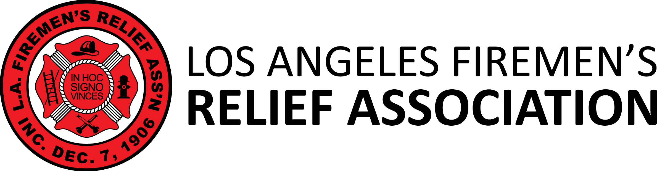

Election of Trustees | 2020
Joe Vigil, Chairman, Election Committee, LAFRA

I, , do hereby submit my name as a candidate for the position of Group 3 Trustee on the Board of Trustees of the Los Angeles Firemen’s Relief Association. This letter is valid only for the General Election of 2020.

BIOGRAPHY/STATEMENT

** Include a PHOTO of yourself along with this letter. (JPEG or PNG files only)

MAIL, EMAIL or FAX TO:

Joe Vigil, Trustee

Los Angeles Firemen’s Relief Association

7470 N. Figueroa Street

Los Angeles, CA 90041
FAX: (323) 259-5290 EMAIL: jvigil@lafra.org

